**Funder Log In:**

After Funder enters his username and password on the Log In page his management account will appear:

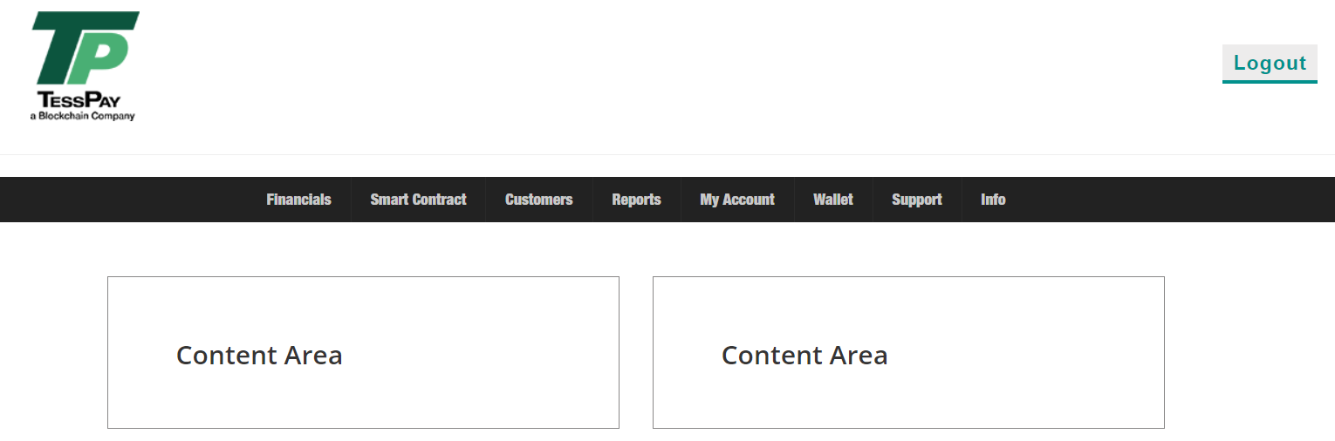

**Financials**

Under financials Funder will have the following options:

1. Balance
2. Tess Fee Invoices
3. Customer Invoices
4. **Balance**

Once the Funder clicks on balance, he will be able to see the current account balance in all currencies (for POC only USD and Tess Coin), he will have the option to withdraw and to top up his wallet balance. Also he will be able to see a statement of account for each currency he owns.

Example:

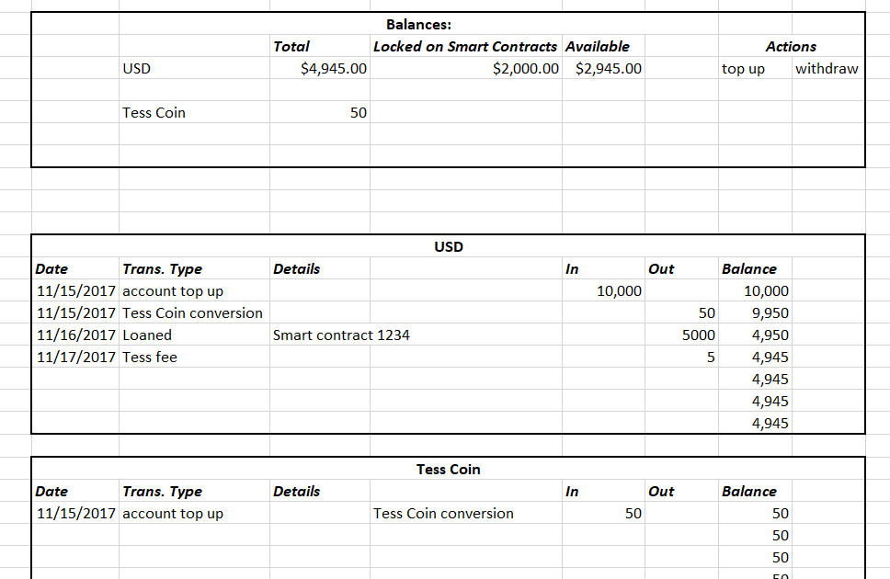

In case Funder selects “top up” he will be redirected to the following page:

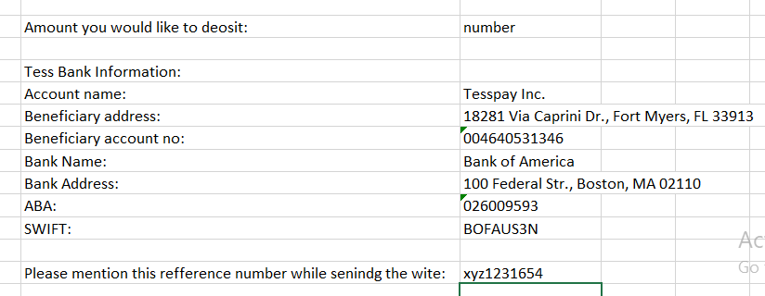

In case Funder selects “withdraw” he will be redirected to the following page:

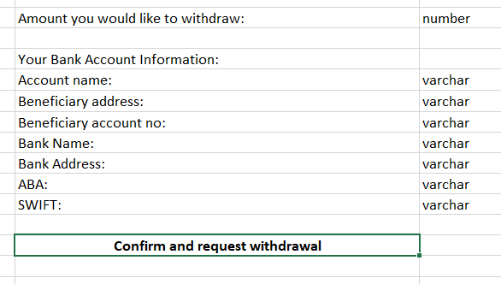

1. **Tess Fee Invoices**

Under this section the Funder will be able to download (I recommend monthly) invoices for the fees charged by Tess on escrow transactions. He will see a list with the invoices and will have a download option

Example:

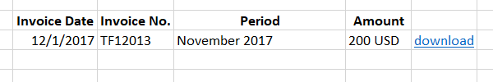

1. **Customer Invoices**

When Funder selects this menu option he will be able to see a list with all the invoices he issued for the interest on loans.

Example:

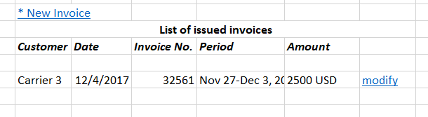

By clicking on “New Invoice” Funder will be able to create manually or to upload invoice for the interest on the loan he provided.

Example:

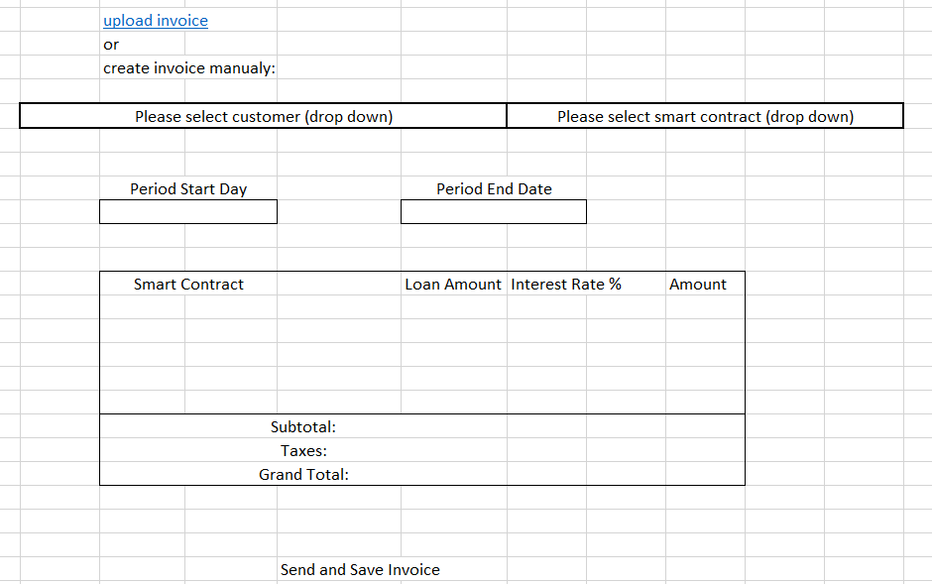

**Smart Contracts**

Under this menu option Funder will see list with all smart contracts, and he will have the option to “Create New Smart Contract”.

Example:

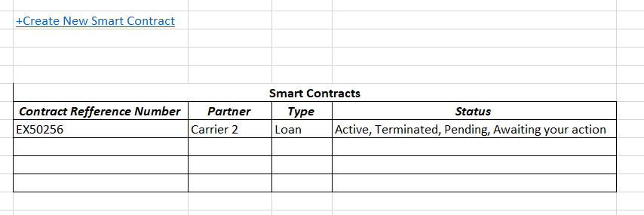

Funder will need to provide the following information when he is creating a new smart contract:

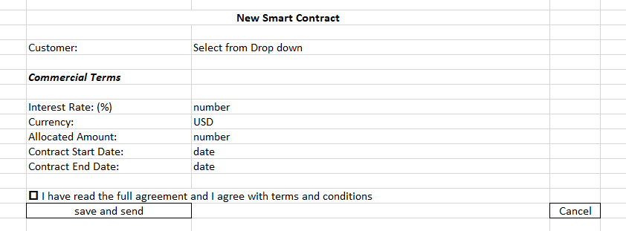

**Customers**

When Funder selects Customers menu option he will see a list with all his customers.



When he clicks on the customer’s name he will see the full customer info provided at registration. And it will give two other tabs (Customer Info, Smart Contracts, Statement of account).

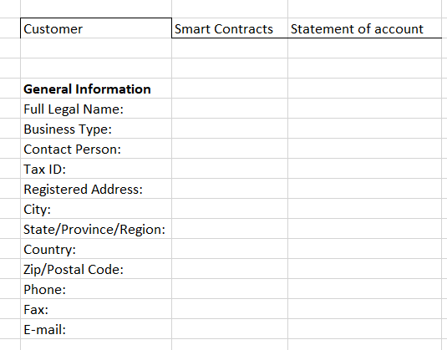

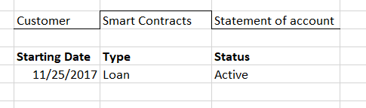

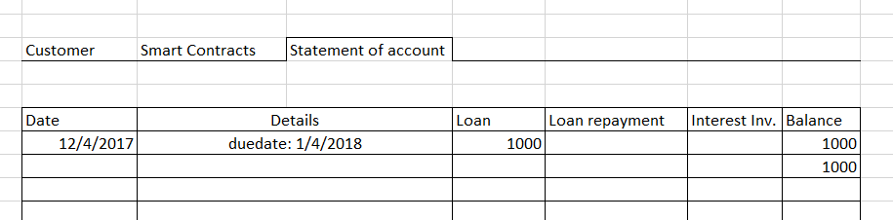

**Reports**

This needs to agree on this. For POC I recommend not to ad reports.

**My Account**

In my account section Funder will have the possibility to modify the information provided at the registration and to reset password:

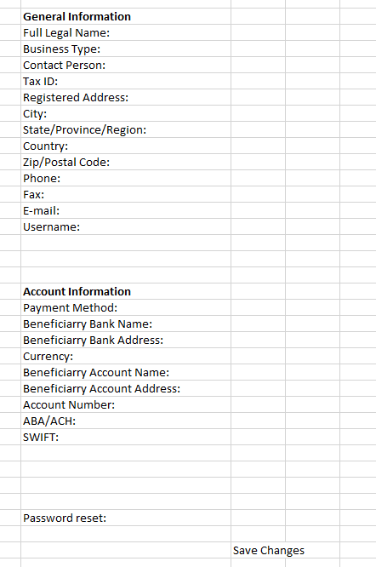

**Wallet**

Wallet menu will look and function exactly like Balance under Financials.